**Azure Databricks Setup Documentation**

**Goal**

The goal of this setup is to configure an Azure Databricks workspace via the Azure Portal, set up a compute cluster, and prepare it to run workloads.

**Steps to Set Up Azure Databricks**

**Step 1: Sign in to Azure Portal**

1. Open https://portal.azure.com in your browser.
2. Sign in using your Azure account credentials.

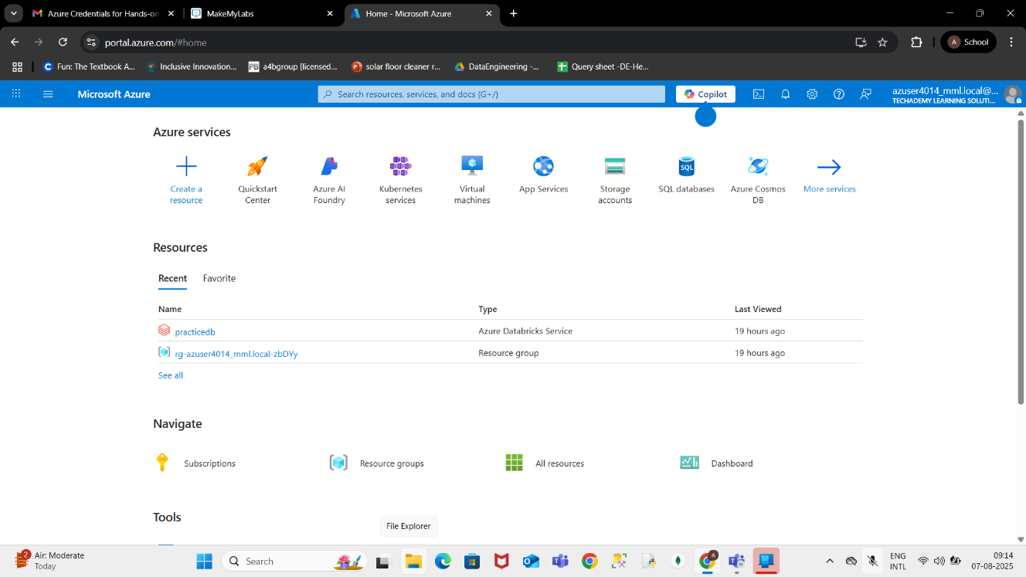

**Step 2: Create a Resource**

On the Azure Portal home page, click Create a resource from the left menu.

In the search bar, type Azure Databricks and select it from the list.

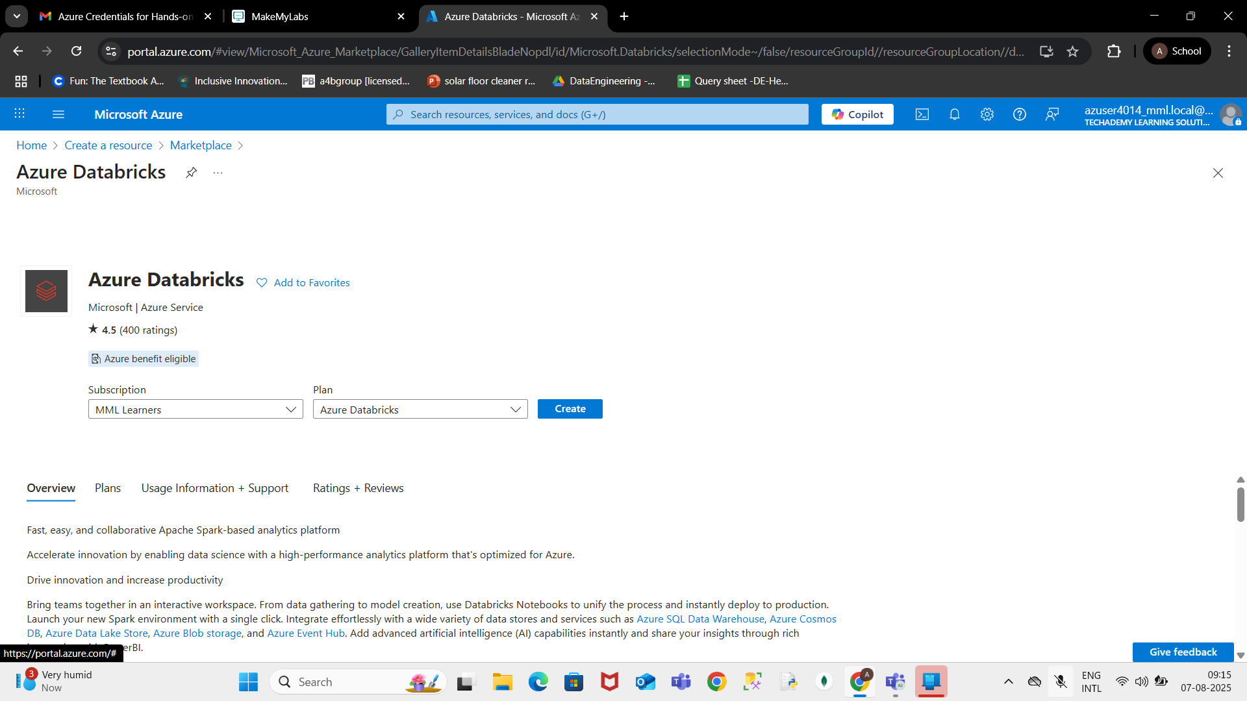

**Step 3: Configure the Workspace**

Click Create.

Fill in the required details:

Subscription: Select your subscription.

Resource Group: Select an existing one or create a new one.

Workspace Name: Enter a unique name.

Region: Choose the nearest region.

Click Review + Create and then Create.

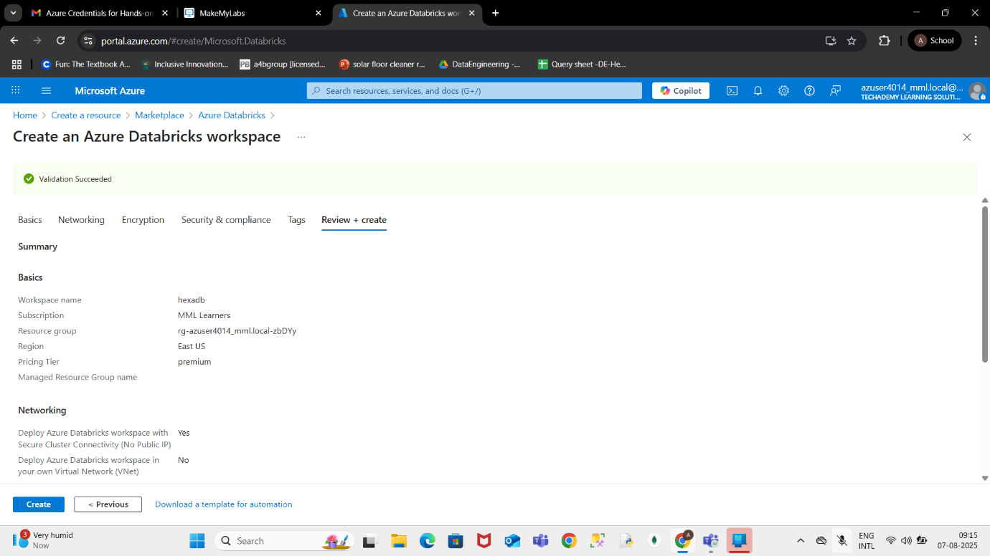

**Step 4: Deployment Complete**

Wait for the deployment to finish.

Once complete, click Go to resource.

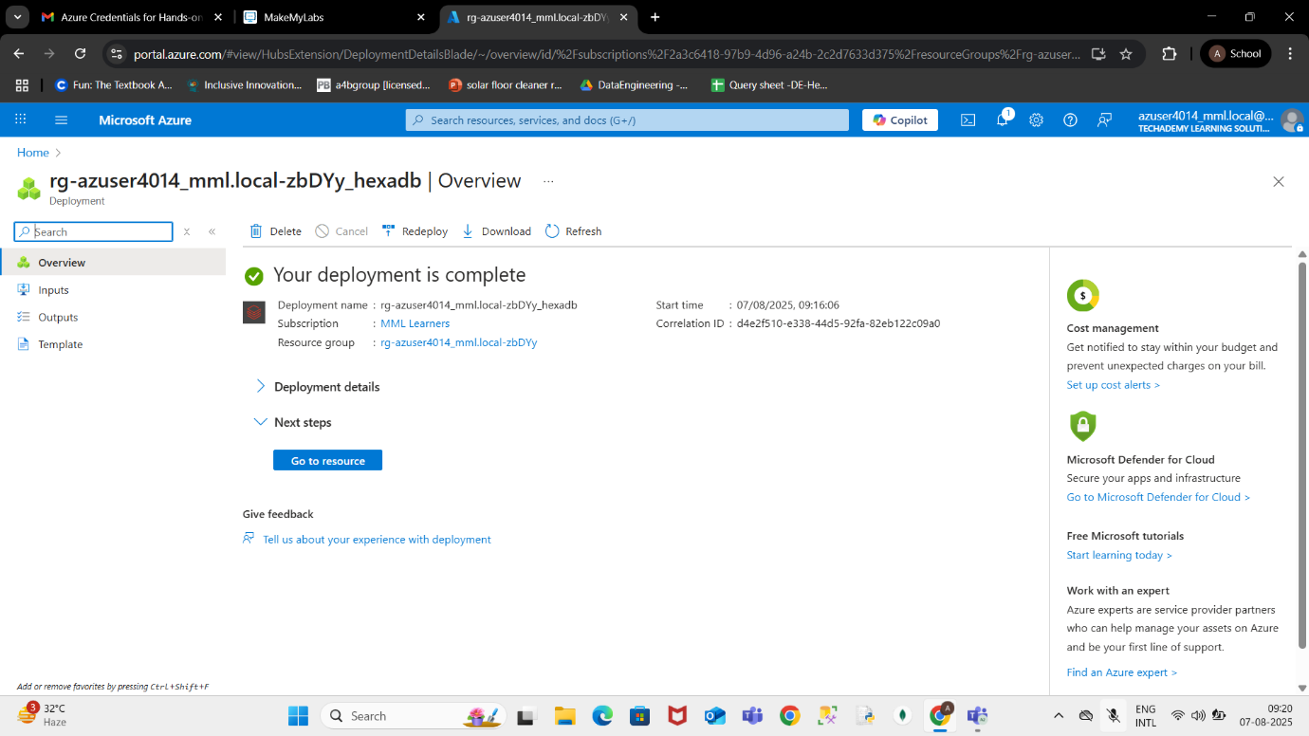

**Step 5: Launch Azure Databricks Workspace**

In the resource page, click Launch Workspace.

This will open the Databricks environment in a new tab.

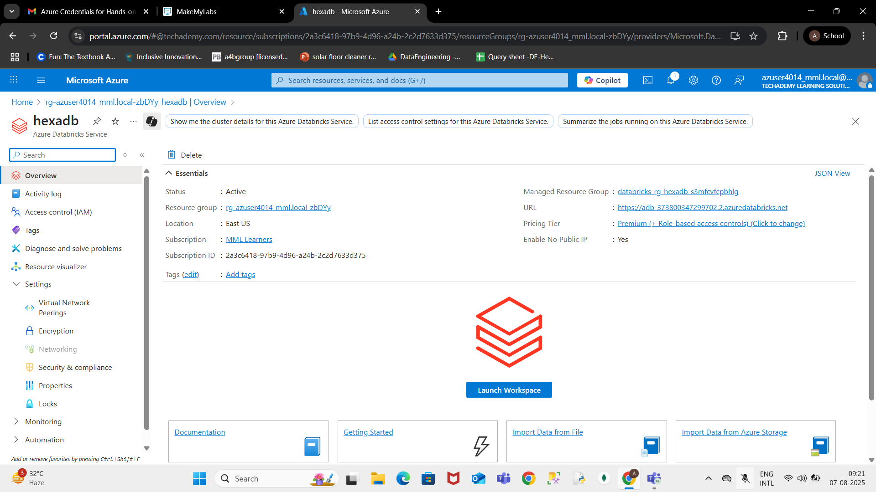

**Step 6: Create a Cluster**

In Databricks, click Compute in the left menu.

Click Create Cluster.

Fill in the cluster details and click Create.

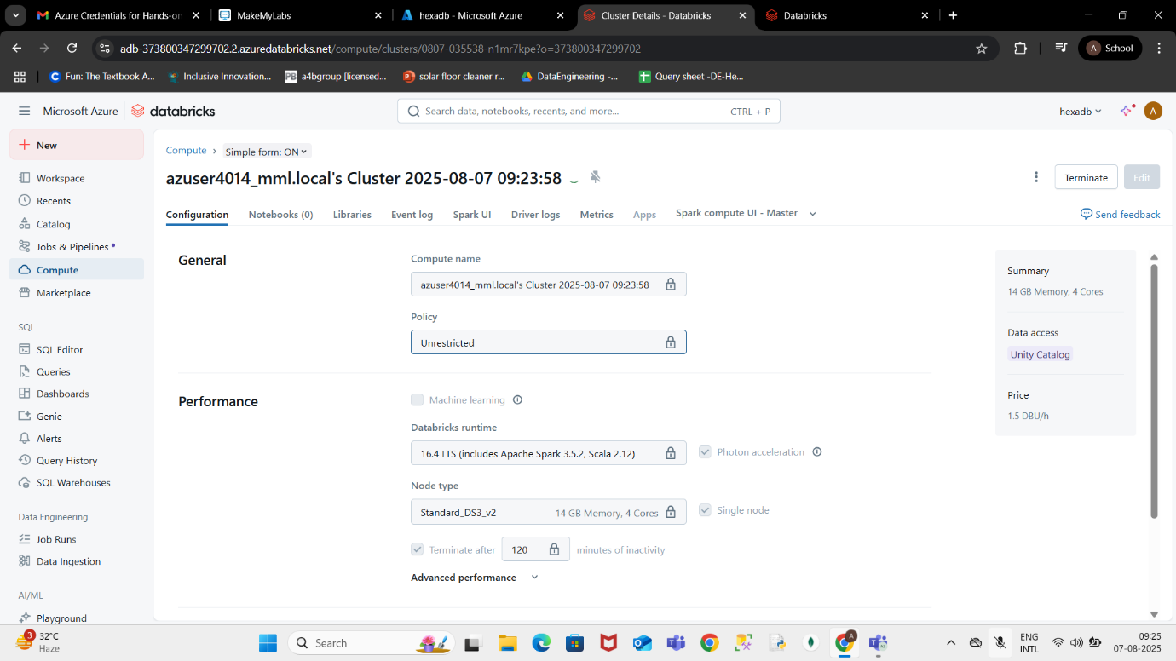

**Conclusion**

You have successfully set up Azure Databricks, created a workspace, and launched a compute cluster ready for running workloads.